Step 1: Created a cloud function which has HTTP as trigger.

- Created a cloud scheduler and configured such that it invokes a HTTP endpoint and which inturns

triggers the cloud function( since we created a HTTP base triggered function )

. 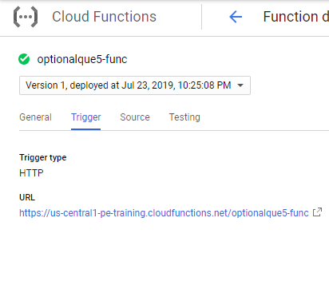
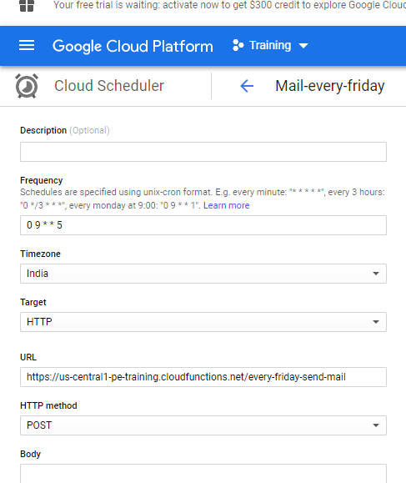

- Created a topic in pub/sub.

- In order to receive email or message , we need to subscribe the pub/sub

- We need an endpoint URL to be assigned to push type pub/sub. (in order to get a URL we need to create some service accounts)

- Cloud function creates a sync and exports the logs of CPU utilization of all the instances and user info. to pub/sub.

- A subscription to pub/sub topic is made by Devops team and they will receive the published message.

